**AUTOMATION INVIGILATION DUTIES**

|  |  |
| --- | --- |
| **CONTENT** | **PAGE NO** |
| **Abstract** |  |
| **1.INTRODUCTION** |  |
| 1.1 Motivation |  |
| 1.2 Problem Statement |  |
| 1.3 Objective of the Project |  |
| 1.4 Scope |  |
| 1.5 Project Introduction |  |
| **2.LITERATURE SURVEY** |  |
| 2.1 Related Work |  |
| **3. SYSTEM ANALYSIS** |  |
| 3.1 Existing System |  |
| 3.2 Disadvantages |  |
| 3.3 Proposed System |  |
| 3.4 Advantages |  |
| 3.5 work Flow of Proposed system |  |
| **4. REQUIREMENT ANALYSIS** |  |
| 4.1Function and non-functional requirements |  |
| 4.2 Hardware Requirements |  |
| 4.3 Software Requirements |  |
| 4.4 Architecture |  |
| **5. SYSTEM DESIGN** |  |
| 5.1 Introduction of Input design |  |
| 5.2 UML Diagram(class, use case, sequence, collaborative, deployment, |  |
| 5.3 Data Flow Diagram |  |
| **6. IMPLEMENTATION AND RESULTS** |  |
| 6.1 Modules |  |
| 6.2 Output Screens |  |
| 1. **JAVA ENVIRONMENT** |  |
| 7.1 Software Installation |  |
| 7.2 About Java Language |  |
| 1. **SYSTEM STUDY AND TESTING** |  |
| 8.1 Feasibility study |  |
| 8.2 Types of test |  |
| **9. CONCLUSION** |  |
| **10. FUTURE ENHANCEMENT** |  |
| **11. REFERENCES** |  |

**ABSTRACT:**

Pre-requisite for conduct of Examination viz competitive school and college level exams, entrance exams etc. requires faculty or staff members to perform invigilation duty. Preparation of invigilation duty list is a tedious work if done manually when large number of invigilators is involved for examination scheduled daily in two or more shifts for large number of days. Here we have discussed development of an automated system that can generate invigilation duty list for any type examination. This automated system will take some required data like staff list, dates of examinations and number of invigilators on the days, as input and, gives the invigilation duty list as output according to fed data. It can be useful for any organization, universities, institutes where examinations are held. One can reduce the time wasted in making the invigilation duty list manually using this automated system.

Keywords: Examination, Invigilation, Invigilator, Duty List.

1. **INTRODUCTION**

**1.1 Motivation:**

Now a days faculty who are going to invigilation they are finding rooms physically and in the examination section .Here in our application faculty can see in at time invigilation duties. In that information details like date, subject and timings all the information quickly in online will get information.

**1.2 Problem Statement:**

Automation invigilation duties is software developed for invigilation duties in all colleges. It facilitates to access the invigilation information of a particular faculty . By just a click on the mouse, the system will be able to produce the invigilation duties report thus reducing the need for work searching somewhere which is prone to human errors and time consuming.

**1.3 Objective of the Project:**

The objective of the project – Automation Invigilation Duties application is as follows:

**“Automation Invigilation Duties”** is software developed for maintaining the invigilation information of the exam. The objective of automation invigilation duties management is to provide a user-friendly and efficient platform that enables faculty to access relevant and up-to-date information about their exam details, check the details by individually who are going exam hall for invigilation.

**1.4 Scope:**

The scope of the project is the system on which the software is installed, i.e, the project is developed as a desktop application. Overall, the scope of automation invigilation duties systems can be quite extensive, and they can provide significant benefits to invigilation information ,date of the particular day and subject details ,timings .

**1.5 Project Introduction:**

Preparing the examination invigilation schedule has always been in itself a challenging task as the examination department has to take into consideration numerous factors and lecturers’ constraints such as getting the invigilation schedules ready within a limited time frame, ensuring the invigilation duties assigned to the lecturers do not disrupt their marking and that the lecturers do not invigilate their own subjects. As the invigilation duties were assigned randomly there was a lot of mutual swapping amongst the lecturers resulting in confusion, misunderstandings, and complaints on uneven duty distribution. Thus, when the present invigilation scheduling committee took over the task of invigilation scheduling , they saw the need for a systematic and yet innovative approach to producing invigilation schedules that could minimize errors and simultaneously allowed lecturers to request for their preferred invigilation dates and time.

1. **LITERATURE SURVEY**

**2.1 Related Work:**

**[1] S. Priya Dharshini, M. Selva Sudha, Mrs. V. Anithalakshmi, “Exam Cell Automation System,” International Journal of Engineering Science and Computing (2017), Volume 7, Issue no3.**

In this paper, examination is a core activity of any educational institution. As the examination arrives there exists a lot of work like consolidating the time table, seating arrangement and invigilation allotment which will be done manually and it takes lot of time and requires man power. Thus, an automated system would solve the above stated problem in just few clicks of work. The purpose of developing Examination Management Automation System is to computerize the traditional way of conducting exams. It is a web and android application that can be used by students and exam cell coordinator using their smart phones or PCs. The project keeps track of various details in modules such as Students Details, Staff Details, and Hall Details with proper descriptions. It also has some features to generate reports for bundle handovers, absentee’s statement and roll lists.

**[2] Dayanand G Savakar, Ravi Hosur, “Automation of Examination System”, International Journal of Science and Research, Volume 4 Issue 11 November 2015.**

In this paper , Allocation of faculty will be done in the excel sheet. And also allocation of thousands of student to particular block is a hectic work and that will be done manually thus it may take lot of time and require man power. Thus, an automated system would solve the above stated problem in just few click work. An automated system can be used through cloud computing technology that facilitates the every college to provide their student and staff information and get the results of allotment. And by this way even University can track the details of allotment with each institute. Cloud computing is defined as a type of computing that relies on sharing computing resources rather than having local servers or personal devices to handle applications. In cloud computing, the word cloud (also phrased as "the cloud") is used as a metaphor for "the Internet" so the phrase cloud computing means "a type of Internet-based computing" where different services — such as servers, storage and applications — are delivered to an organization's computers and devices through the Internet. Cloud computing is comparable to grid computing, a type of computing where unused processing cycles of all computers in a network are harnesses to solve problems too intensive for any standalone machine.

**[3]**  **DigitalPersona Incorporation (2012), Best Practices for implementing Fingerprint Biometrics in Application. A Whitepaper**

The paper , presents embodiments may take the form of devices and methods to help expedite matching biometric data in a validation process. One embodiment, for example, may take the form of a method for biometric validation including receiving a biometric input and retrieving metadata data of a most recently matched template. The method also includes evaluating the metadata and selecting one or more nodes from the most recently matched template for comparison. Additionally, the method includes comparing the selected one or more nodes with the received biometric input and determining if the selected one or more nodes match with the received biometric input. Also, the method includes validating the received biometric input if the selected one or more nodes match with the received biometric input.

**[4] Josphineleela R. and Ramakrishnan M. (2012). An efficient Automatic system using Fingerprint Reconstruction Technique. International Journal of Computer Science and Information Security, 10(3):1-6**

In this paper, Biometric time and attendance system is one of the most successful applications of biometric technology. One of the main advantage of a biometric time and attendance system is it avoids "buddy-punching". Buddy punching was a major loophole which will be exploiting in the traditional time attendance systems. Fingerprint recognition is an established field today, but still identifying individual from a set of enrolled fingerprints is a time taking process. Most fingerprint-based biometric systems store the minutiae template of a user in the database. It has been traditionally assumed that the minutiae template of a user does not reveal any information about the original fingerprint. This belief has now been shown to be false; several algorithms have been proposed that can reconstruct fingerprint images from minutiae templates. In this paper, a novel fingerprint reconstruction algorithm is proposed to reconstruct the phase image, which is then converted into the grayscale image. The proposed reconstruction algorithm reconstructs the phase image from minutiae. The proposed reconstruction algorithm is used to automate the whole process of taking attendance, manually which is a laborious and troublesome work and waste a lot of time, with its managing and maintaining the records for a period of time is also a burdensome task.

**[5] Indu Sharma, Anjali Singhal, Research on Online Examination System, International Journal of Engineering Technology, Management and Applied Sciences,Volume 2 Issue 3, August 2014**

In this paper, the quality of education is to a major extent assessed through examination and therefore examination is an inseparable and integral part of education. Even though we have seen a lot of technological advancements, the examination process is still carried out the traditional way with most of the process performed manually. As a result of which the current system at times are prone to errors and are time consuming. Various techniques have been proposed to automate the time table generation, automatic paper setting and evaluation. One of the tasks that has not got much attention is the assignment of work on a per day basis to invigilators and their assignment to rooms for invigilation. So we propose a system that integrates task like invigilator allotment, room allotment student allotment and time table generation in an efficient way.

**[6] Ong, M. L., Liew, L. H. and Sim, J. (2006). Examination Invigilation Scheduling System In Optimising Lecturers’ Preference. UiTM Sarawak: Unit of Research, Development, and Commercialization (URDC), Sarawak: University Teknologi Mara**

In this paper, the examinations Invigilation Scheduling System aims to reduce manual involvement and amount of time taken by the invigilation scheduling committee in preparing the final examinations invigilation schedule. This is made possible with the creation of a database that collects information pertaining to the examinations invigilation schedule such as lecturers' preferences and constraints of the invigilation designing process. This system is beneficial especially to the Academic Administration Office of institutions of higher learning because it enables them to produce comprehensive examinations invigilation schedule. Besides that, being computer-aided and accessible by lecturers on-line, it allows lecturers to choose their preferences, provide feedback and any other relevant information, and at the same time obtain a summary of their invigilation schedule even while away from the office. This automated way of capturing, optimising and disseminating invigilation information paves the way for the development of a systematic approach in preparing examinations invigilation schedule. With that, suitable problem-solving support system which will aid the process of computerising examinations invigilation scheduling system can be identified.

**3. SYSTEM ANALYSIS**

**3.1 Existing System**

In the present scenario, the task of invigilation scheduling involves all the lecturing staff who follows a set of invigilation schedule that is prepared manually by the examination department in the college. However, a lot of tasks are required in order to organize an examination from the college such as assigning a set of proctors to each examination room and assigning a seating layout for each examination room. These tasks usually involve a lot of data from many sources and require more time

**3.2** **Disadvantages**

**1.** **Not User Friendly:** The existing system is not user friendly because the retrieval of data is very slow and data is not maintained efficiently.

**2.** **Difficulty in report generating:** We can’t able see the all the invigilation information. And the faculty not get at the time of searching for exam hall.

**3.** **Time consuming:** Every work is done manually so we cannot get the information in the middle of the tour or as per the requirement because it is very time consuming.

**3.3 Proposed System**

The propose system is highly automated and makes the invigilation information much easier and flexible. The faculty can get the very right information at the very right time. The system is expected to increase the efficiency in the allocation rooms to the faculty members who are going to invigilate during the examination. Therefore, it will decrease the work hours and manpower.

**3.4 Advantages**

**1.** **User Friendly:** - The proposed system is user friendly because the retrieval and storing of data is fast and data is maintained efficiently. Moreover the graphical user interface is provided in the proposed system, which provides user to deal with the system very easily.

**2.** **Reports are easily generated:** reports can be easily generated in the proposed system so user can get information at anytime

**3. Very less work:** The proposed system requires very less work. All the data is fetched into the computer immediately and reports can be generated through computers. Moreover work becomes very easy because there is no need to keep data on papers.

**4. Computer operator control:** Computer operator control will be there so no chance of errors. Moreover storing and retrieving of information is easy. So work can be done speedily and in time.

**3.5 work Flow of Proposed system**

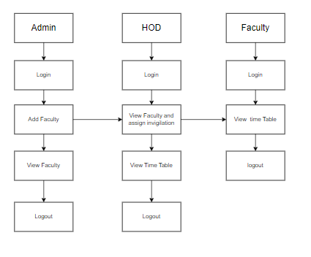

**4. REQUIREMENT ANALYSIS**

**4.1 Functional and non-functional requirements**

Requirement’s analysis is very critical process that enables the success of a system or software project to be assessed. Requirements are generally split into two types: Functional and non-functional requirements.

**Functional Requirements**: These are the requirements that the end user specifically demands as basic facilities that the system should offer. All these functionalities need to be necessarily incorporated into the system as a part of the contract. These are represented or stated in the form of input to be given to the system, the operation performed and the output expected. They are basically the requirements stated by the user which one can see directly in the final product, unlike the non-functional requirements.

Examples of functional requirements:

1. Authentication of user whenever he/she logs into the system
2. System shutdown in case of a cyber-attack
3. A verification email is sent to user whenever he/she register for the first time on some software system.

**Non-functional requirements**: These are basically the quality constraints that the system must satisfy according to the project contract. The priority or extent to which these factors are implemented varies from one project to other. They are also called non-behavioral requirements.  
They basically deal with issues like:

* Portability
* Security
* Maintainability
* Reliability
* Scalability
* Performance
* Reusability
* Flexibility

Examples of non-functional requirements:

1. Emails should be sent with a latency of no greater than 12 hours from such an activity.
2. The processing of each request should be done within 10 seconds
3. The site should load in 3 seconds whenever of simultaneous users are > 10000
   1. **Hardware Requirements**

# Processor - I3/Intel Processor

Hard Disk - 160GB

Key Board - Standard Windows Keyboard

Mouse - Two or Three Button Mouse

Monitor - SVGA

RAM - 8GB

* 1. **Software Requirements:**

Operating System : Windows 7/8/10

Server side Script : HTML, CSS,& JS

Programming Language : Java

IDE/Workbench : Intellij Idea

Technology : java 1.8

Server : Tomcat Server

Database : MySQL

* 1. 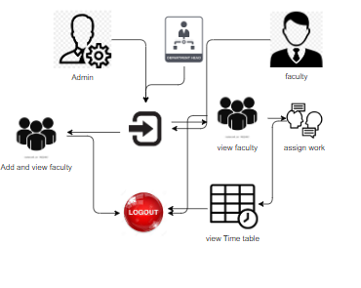
  2. **Architecture:**

**5. SYSTEM DESIGN**

**5.1 Introduction of Input Design:**

In an information system, input is the raw data that is processed to produce output. During the input design, the developers must consider the input devices such as PC, MICR, OMR, etc.

Therefore, the quality of system input determines the quality of system output. Well-designed input forms and screens have following properties −

* It should serve specific purpose effectively such as storing, recording, and retrieving the information.
* It ensures proper completion with accuracy.
* It should be easy to fill and straightforward.
* It should focus on user’s attention, consistency, and simplicity.
* All these objectives are obtained using the knowledge of basic design principles regarding −
  + What are the inputs needed for the system?
  + How end users respond to different elements of forms and screens.

### **Objectives for Input Design:**

The objectives of input design are −

* To design data entry and input procedures
* To reduce input volume
* To design source documents for data capture or devise other data capture methods
* To design input data records, data entry screens, user interface screens, etc.
* To use validation checks and develop effective input controls.

**Output Design:**

The design of output is the most important task of any system. During output design, developers identify the type of outputs needed, and consider the necessary output controls and prototype report layouts.

### Objectives of Output Design:

The objectives of input design are:

* To develop output design that serves the intended purpose and eliminates the production of unwanted output.
* To develop the output design that meets the end user’s requirements.
* To deliver the appropriate quantity of output.
* To form the output in appropriate format and direct it to the right person.
* To make the output available on time for making good decisions.

**5.2 UML Diagrams:**

**5.2.1 Use Case Diagram:**

A use case diagram in the Unified Modeling Language (UML) is a type of behavioral diagram defined by and created from a Use-case analysis. Its purpose is to present a graphical overview of the functionality provided by a system in terms of actors, their goals (represented as use cases), and any dependencies between those use cases. The main purpose of a use case diagram is to show what system functions are performed for which actor. Roles of the actors in the system can be depicted.

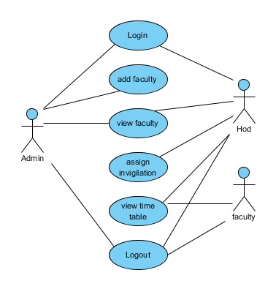

**5.2.2 Class Diagram:**

In software engineering, a class diagram in the Unified Modelling Language (UML) is a type of static structure diagram that describes the structure of a system by showing the system's classes, their attributes, operations (or methods), and the relationships among the classes. It explains which class contains information.

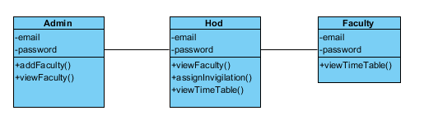

**5.2.3 Sequence Diagram:**

A sequence diagram in Unified Modelling Language (UML) is a kind of interaction diagram that shows how processes operate with one another and in what order. It is a construct of a Message Sequence Chart. Sequence diagrams are sometimes called event diagrams, event scenarios, and timing diagrams.

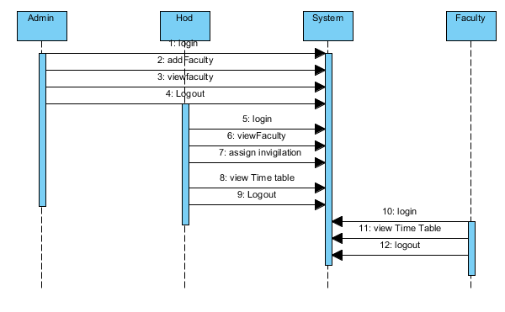

**5.2.4 Collaboration Diagram:**

In collaboration diagram the method call sequence is indicated by some numbering technique as shown below. The number indicates how the methods are called one after another. We have taken the same order management system to describe the collaboration diagram. The method calls are similar to that of a sequence diagram. But the difference is that the sequence diagram does not describe the object organization whereas the collaboration diagram shows the object organization.

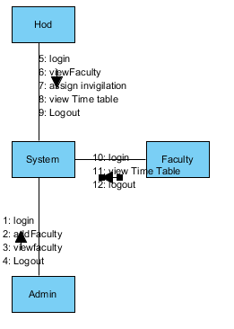

**5.2.5 Deployment Diagram**

Deployment diagram represents the deployment view of a system. It is related to the component diagram. Because the components are deployed using the deployment diagrams. A deployment diagram consists of nodes. Nodes are nothing but physical hardware’s used to deploy the application.

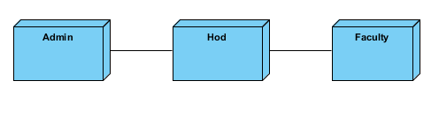

**5.2.6 Activity Diagram:**

Activity diagrams are graphical representations of workflows of stepwise activities and actions with support for choice, iteration and concurrency. In the Unified Modelling Language, activity diagrams can be used to describe the business and operational step-by-step workflows of components in a system. An activity diagram shows the overall flow of control.

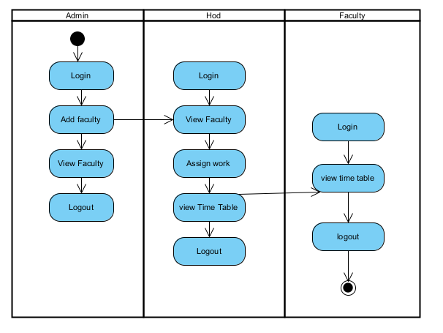

**5.2.7 Component Diagram**:

A component diagram, also known as a UML component diagram, describes the organization and wiring of the physical **c**omponents in a system. Component diagrams are often drawn to help model implementation details and double-check that every aspect of the system's required functions is covered by planned development.

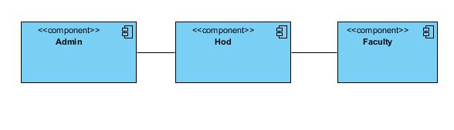

**5.2.8 ER Diagram:**

An Entity–relationship model (ER model) describes the structure of a database with the help of a diagram, which is known as Entity Relationship Diagram (ER Diagram). An ER model is a design or blueprint of a database that can later be implemented as a database. The main components of E-R model are: entity set and relationship set.

An ER diagram shows the relationship among entity sets. An entity set is a group of similar entities and these entities can have attributes. In terms of DBMS, an entity is a table or attribute of a table in database, so by showing relationship among tables and their attributes, ER diagram shows the complete logical structure of a database. Let’s have a look at a simple ER diagram to understand this concept.

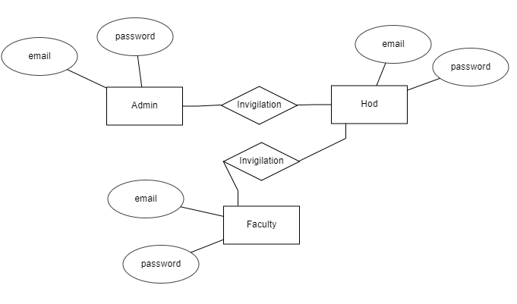

**5.3 DFD Diagram:**

A Data Flow Diagram (DFD) is a traditional way to visualize the information flows within a system. A neat and clear DFD can depict a good amount of the system requirements graphically. It can be manual, automated, or a combination of both. It shows how information enters and leaves the system, what changes the information and where information is stored. The purpose of a DFD is to show the scope and boundaries of a system as a whole. It may be used as a communications tool between a systems analyst and any person who plays a part in the system that acts as the starting point for redesigning a system.

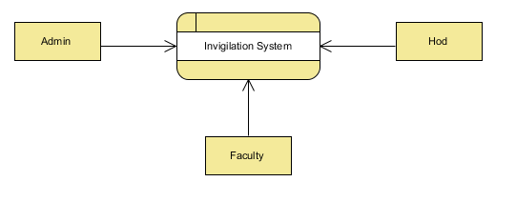

**Level 1 Diagram:**

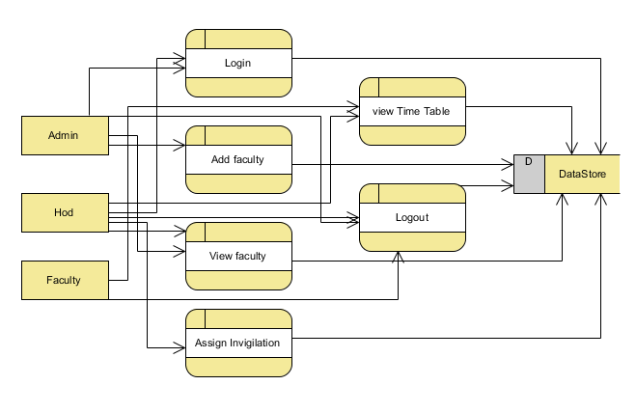

**Level 2 Diagram:**

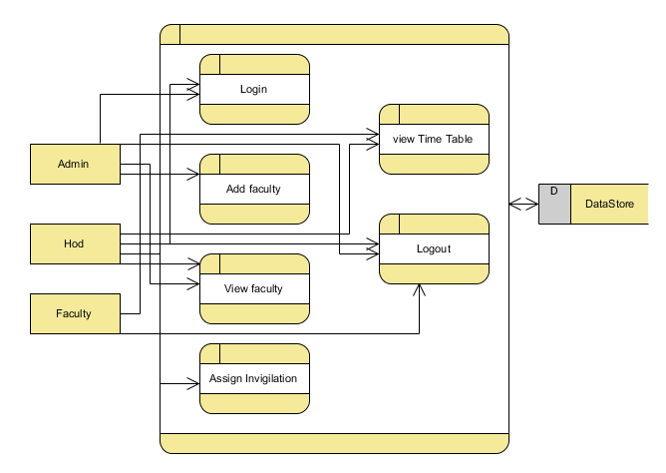

**IMPLEMENTATION AND RESULTS**

**6.1 Modules:**

In this application involved four characters to implement this process they are Admin, Faculty, Hod.

**Admin :** Admin is person to maintain the whole application.

Operation-**Login:** admin will login into the application by entering the valid details like (username and password).

Operation- **Add Faculty/View Faculty:** Add, Read

**Add Faculty:** Admin will add the faculty with their details like( Name, Email , Phone Number , Department). After submitting the details system will send details to hod.

Operation- **View Faculty:** He can view all the faculty who are added by himself.

**Faculty :** Faculty is person to visit for his Time table in the invigilation details.

**Login:** faculty will login into the application by entering the valid details like (username and password).

Operation- **View Time Table:** Read data.

**View Time Table:**  After assigning invigilation duties to faculty , faculty can view that time table details.

**Hod :** Hod is person to assigning invigilation for the all faculty.

Operation-**Login:** hod will login into the application by entering the valid details like (username and password).

Operation- **View Faculty/View Time Table:** Read faculty for assign invigilation, View time table.

**View Faculty:**  Hod can view all the faculty which are added by admin. He can assign the for invigilation to the all faculty.

**View Time Table:**  After assigning invigilation duties to faculty , he can view that time table details.

**6.2 Results:**

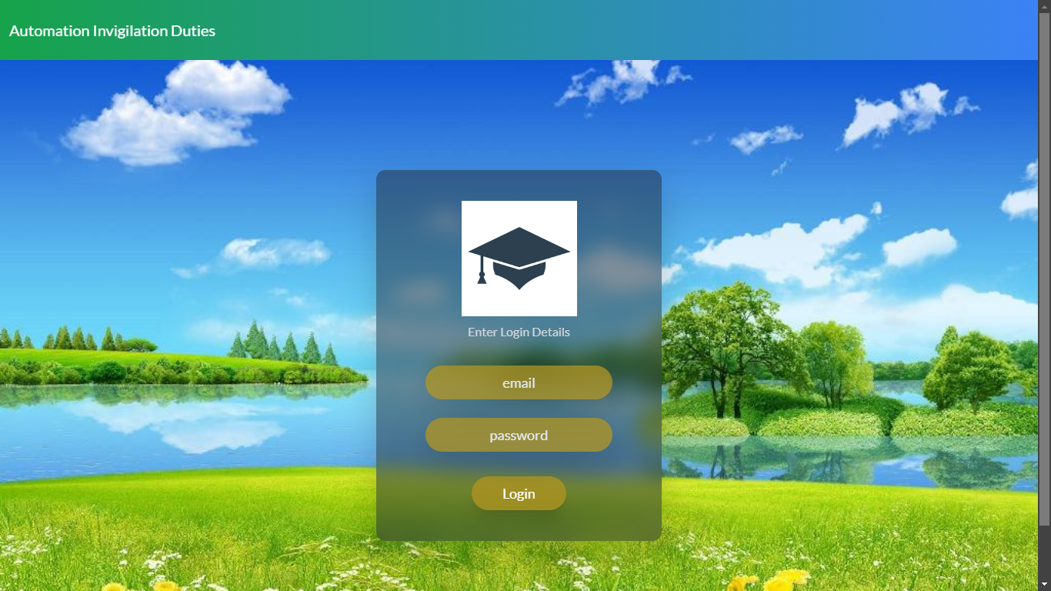

**Home page**: This is an our project home page. Here login is for hod, admin and faculty.

Here the Admin will login through email and password to enter in admin home page. Similarly

Hod and Faculty

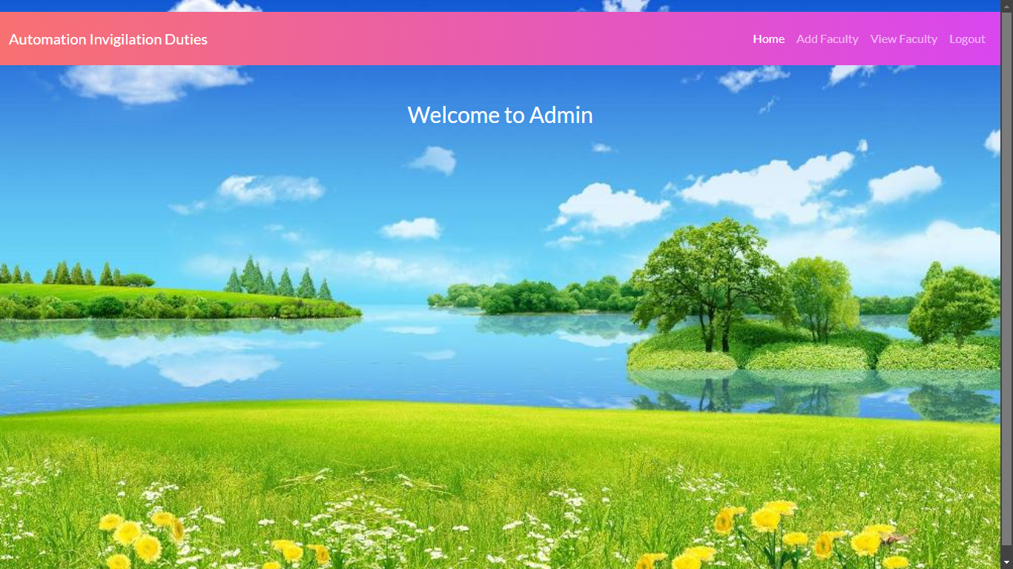

**Admin Home page**: This is the Admin home page.

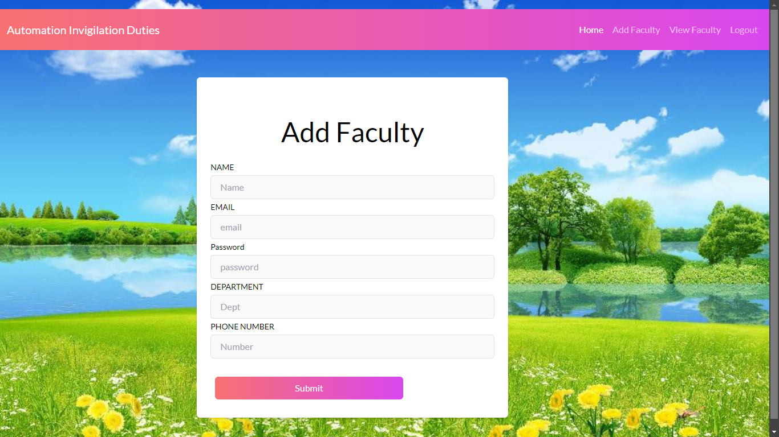

**Add Faculty**: After the Admin login he can add faculty.

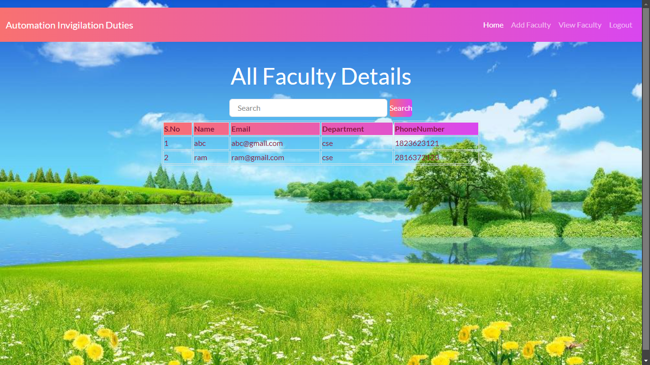

**View Faculty**: After adding faculty details he can view who are added.



**Exam Coordinator Home page**: This is the exam coordinator home page.

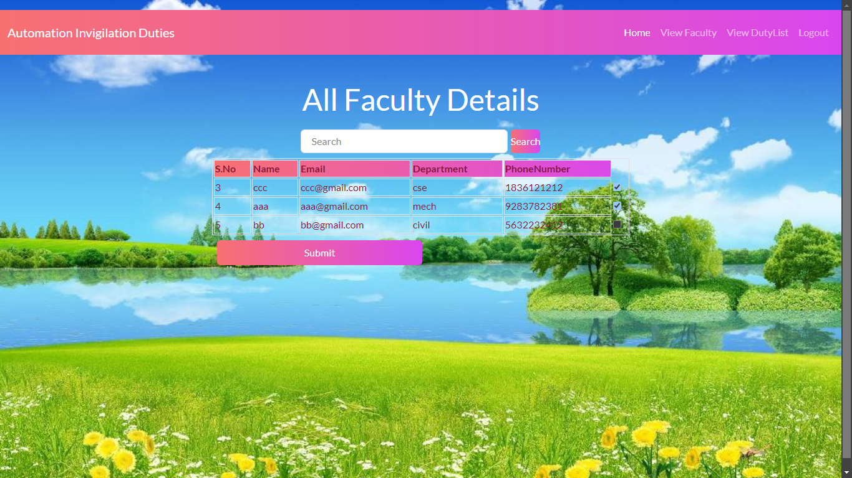

**View Faculty**: After adding faculty details by admin . Coordinator can view the faculty and can assign invigilation duties.

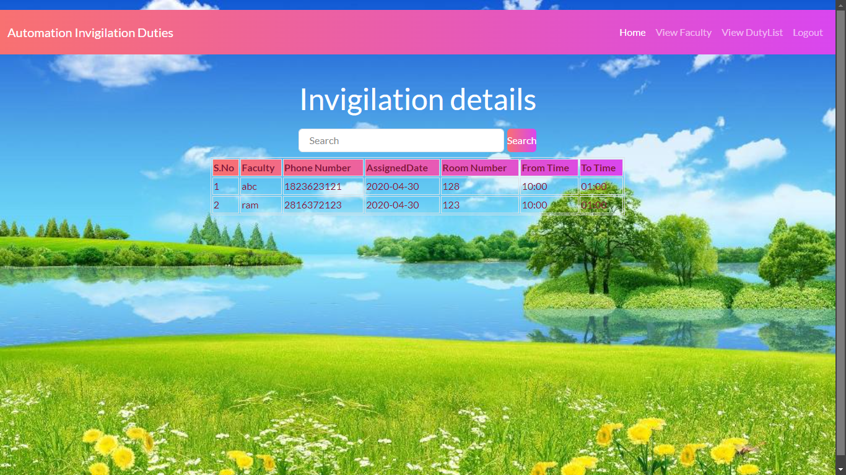

**View Duty List**: After assigning invigilation duties for faculty .he can view that time table .

**7. JAVA ENVIRONMENT**

**7.1 Software Installation**

This Java Development Kit(JDK) allows you to code and run Java programs. It's possible that you install multiple JDK versions on the same PC. But It’s recommended that you install only latest version.

## How to install Java for Windows

Following are the steps for JDK 8 free download for 32 bit or JDK 8 download 64 bit and installation

**Step 1)** Go to [link](https://www.oracle.com/java/technologies/javase-downloads.html). Click on JDK Download for Java

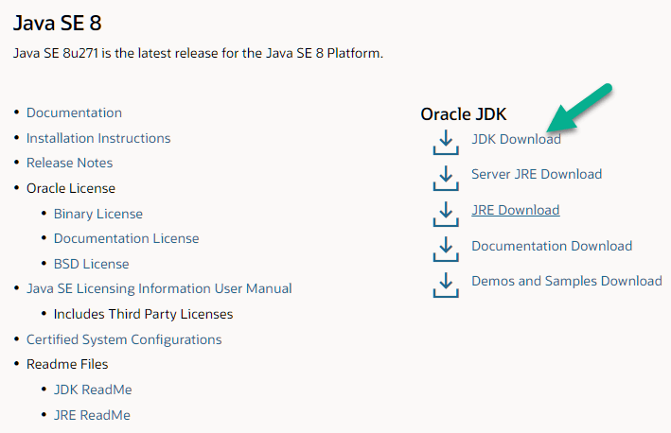

**Step 2)** Next,

1. Accept License Agreement
2. Download Java 8 JDK for your version 32 bit or JDK 8 download for windows 10 64 bit.

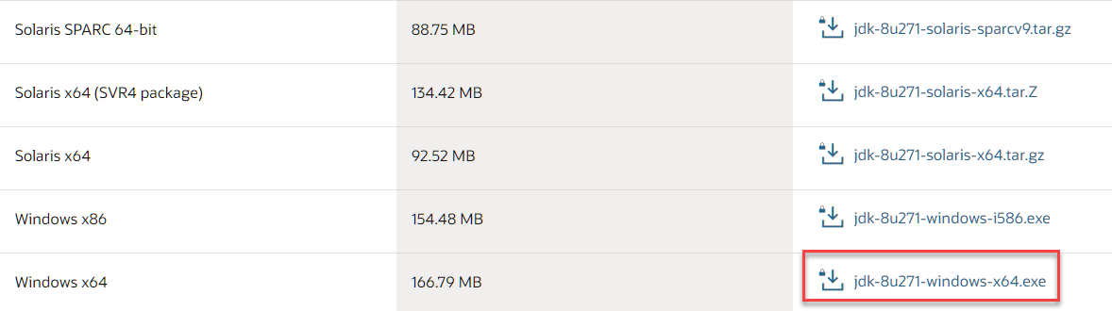

**Step 3)** when you click on the Installation link the popup will be open. Click on I reviewed and accept the Oracle Technology Network License Agreement for Oracle Java SE and you will be redirected to the login page. If you don't have an oracle account you can easily sign up by adding basics details of yours.

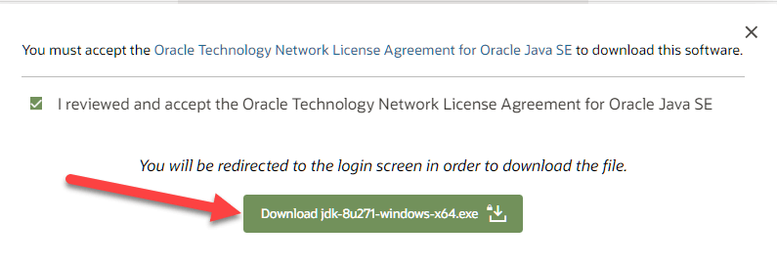

**Step 4)** Once the Java JDK 8 download is complete, run the exe for install JDK. Click Next

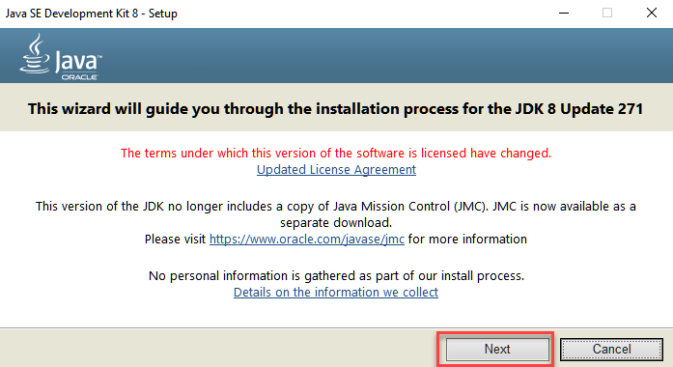

**Step 5)** Select the PATH to install Java in Windows and click next.

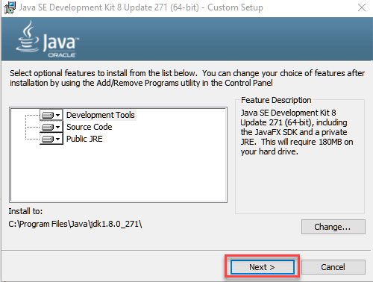

**Step 6)** Once you install Java in windows, click close

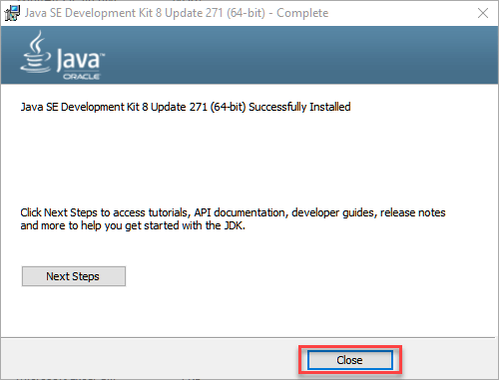

## How to set Environment Variables in Java: Path and Class path

The PATH variable gives the location of executable like javac, java etc. It is possible to run a program without specifying the PATH but you will need to give full path of executable like **C:\Program Files\Java\jdk-13.0.1\bin\javac A.java** instead of simple **javac A.java**

The CLASSPATH variable gives location of the Library Files.

Let's look into the steps to set the PATH and CLASSPATH

**Step 1)** Right Click on the My Computer and Select the properties



**Step 2)** Click on advanced system settings

**Step 3)** Click on Environment Variables

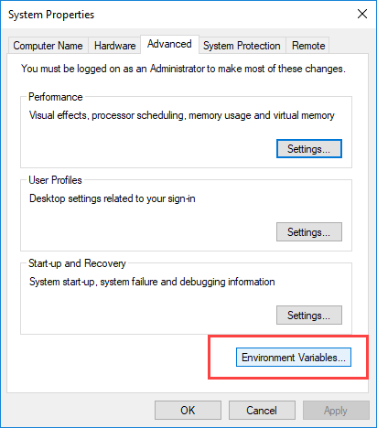

**Step 4)** Click on new Button of User variables

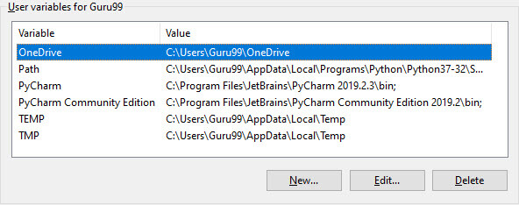

**Step 5)** Type PATH in the Variable name.

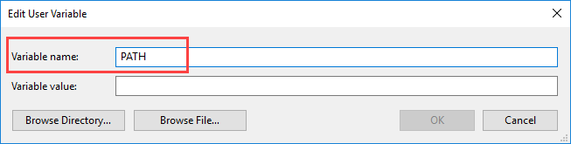

**Step 6)** Copy the path of bin folder which is installed in JDK folder.

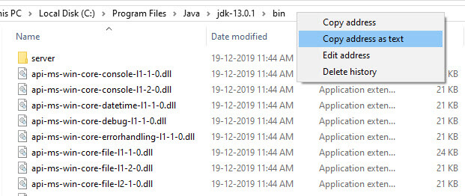

**Step 7)** Paste Path of bin folder in Variable value and click on OK Button.

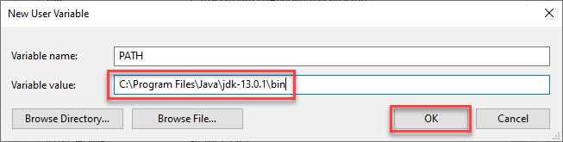

**Note:** In case you already have a PATH variable created in your PC, edit the PATH variable to

PATH = <JDK installation directory>\bin;%PATH%;

Here, %PATH% appends the existing path variable to our new value

**Step 8)**You can follow a similar process to set CLASSPATH.

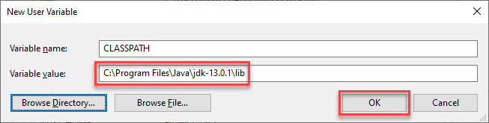

**Note:** In case you java installation does not work after installation, change classpath to

CLASSPATH = <JDK installation directory>\lib\tools.jar;

**Step 9)** Click on OK button

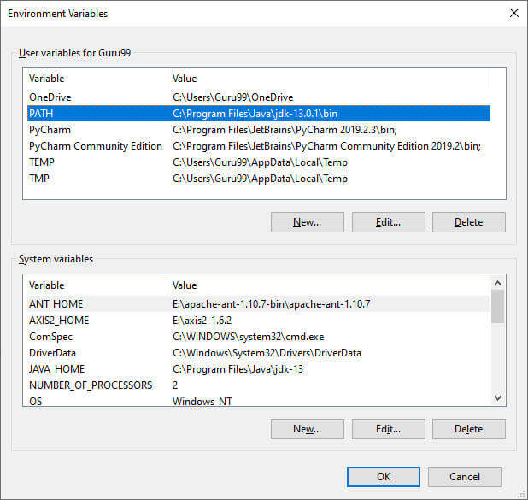

**Step 10)** Go to command prompt and type javac commands.

If you see a screen like below, Java is installed.

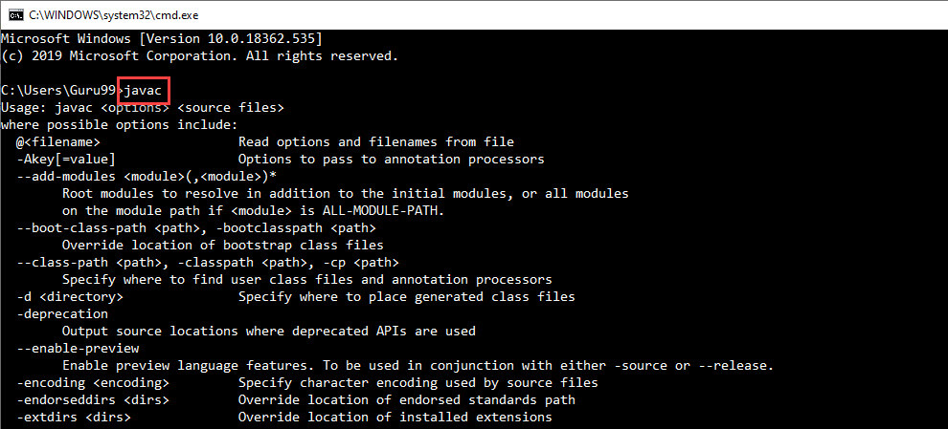

**INSTALLING JAVA AND INTELLIJ IDEA**

**Installing java:**

This Java Development Kit(JDK) allows you to code and run Java programs. It's possible that you install multiple JDK versions on the same PC. But It’s recommended that you install only latest version.

## How to install Java for Windows

Following are the steps for JDK 8 free download for 32 bit or JDK 8 download 64 bit and installation

**Step 1)** Go to [link](https://www.oracle.com/java/technologies/javase-downloads.html). Click on JDK Download for Java



**Step 2)** Next,

1. Accept License Agreement
2. Download Java 8 JDK for your version 32 bit or JDK 8 download for windows 10 64 bit.



**Step 3)** when you click on the Installation link the popup will be open. Click on I reviewed and accept the Oracle Technology Network License Agreement for Oracle Java SE and you will be redirected to the login page. If you don't have an oracle account you can easily sign up by adding basics details of yours.



**Step 4)** once the Java JDK 8 download is complete, run the exe for install JDK. Click Next



**Step 5)** Select the PATH to install Java in Windows and click next.



**Step 6)** Once you install Java in windows, click close



## How to set Environment Variables in Java: Path and Class path

The PATH variable gives the location of executable like javac, java etc. It is possible to run a program without specifying the PATH but you will need to give full path of executable like **C:\Program Files\Java\jdk-13.0.1\bin\javac A.java** instead of simple **javac A.java**

The CLASSPATH variable gives location of the Library Files.

Let's look into the steps to set the PATH and CLASSPATH

**Step 1)** Right Click on the My Computer and Select the properties



**Step 2)** Click on advanced system settings

**Step 3)** Click on Environment Variables



**Step 4)** Click on new Button of User variables



**Step 5)** Type PATH in the Variable name.



**Step 6)** Copy the path of bin folder which is installed in JDK folder.



**Step 7)** Paste Path of bin folder in Variable value and click on OK Button.



**Note:** In case you already have a PATH variable created in your PC, edit the PATH variable to

PATH = <JDK installation directory>\bin;%PATH%;

Here, %PATH% appends the existing path variable to our new value

**Step 8)**You can follow a similar process to set CLASSPATH.



**Note:** In case you java installation does not work after installation, change classpath to

CLASSPATH = <JDK installation directory>\lib\tools.jar;

**Step 9)** Click on OK button



**Step 10)** Go to command prompt and type javas commands.

If you see a screen like below, Java is installed.



Installing intellij idea:

1. To download Intellij visit the website https://www.jetbrains.com/idea/download/#section=windows and Click the "DOWNLOAD" link under the Community Section.

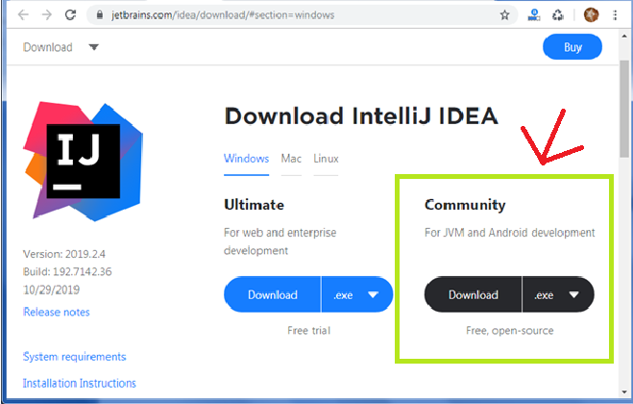

1. Once the download is complete, run the exe for install Intellij. The setup wizard should have started. Click “Next”.
2. On the next screen, Change the installation path if required. Click “Next”.
3. On the next screen, you can create a desktop shortcut if you want and click on “Next”.
4. Choose the start menu folder. Keep selected Jet Brains and click on “Install”.
5. Wait for the installation to finish.
6. Once installation finished, you should receive a message screen that Intellij is installed. If you want to go ahead and run it, click the “Run Intellij Community Edition” box first and click “Finish”.
7. After you click on "Finish," the Following screen will appear.

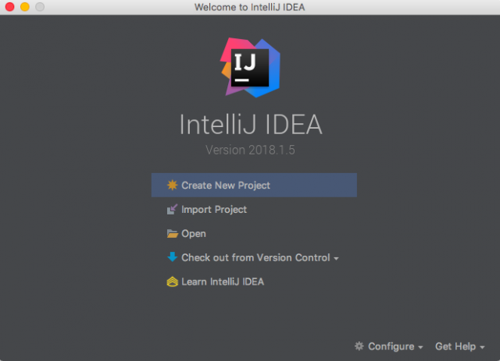

**Installing visual studio code**

Steps to installing visual studio code:

Step 1: Head over to the website <https://code.visualstudio.com/download>

Step2:choose the option as per your choice.

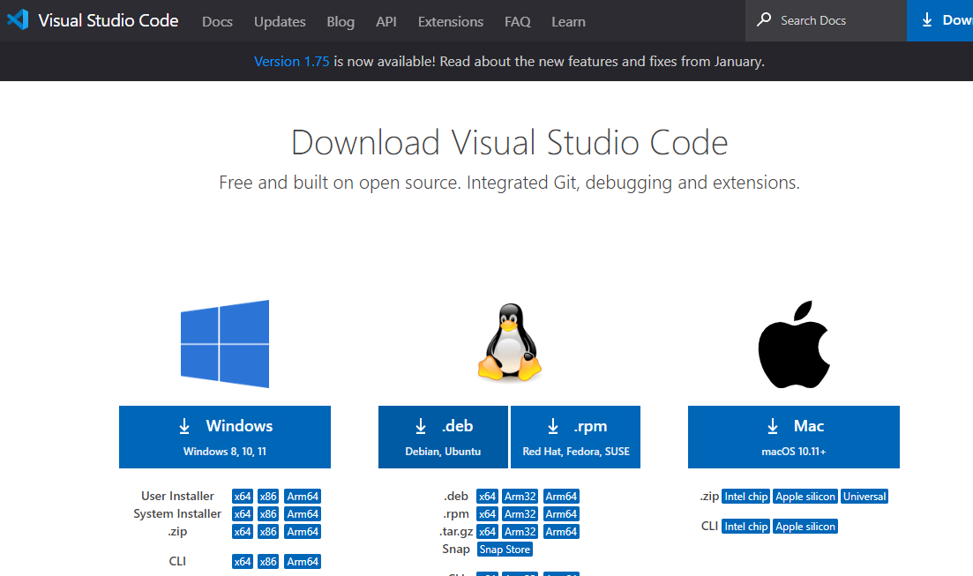

Step 3: Once download completed,open it and your screen will appear like this

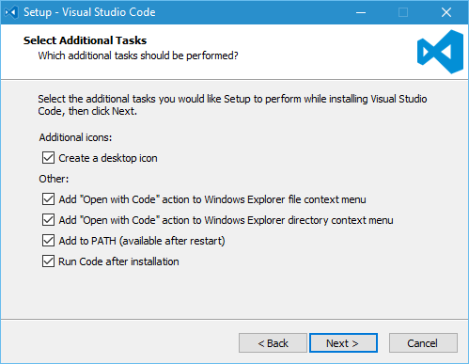

Step 4: click next until you saw the below page

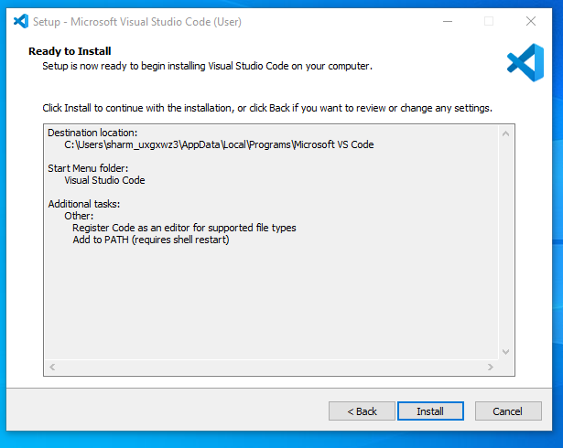

Step 4: After installation your screen will appear like this ,click finish and continue.

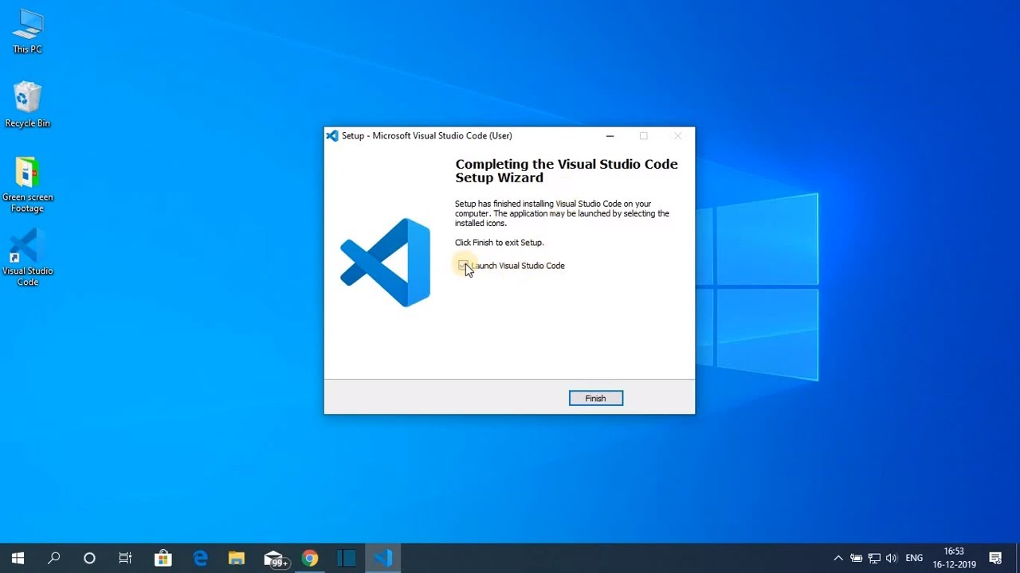

**Installing mysql**

Step 1: Go to the official website <https://www.mysql.com/downloads/>

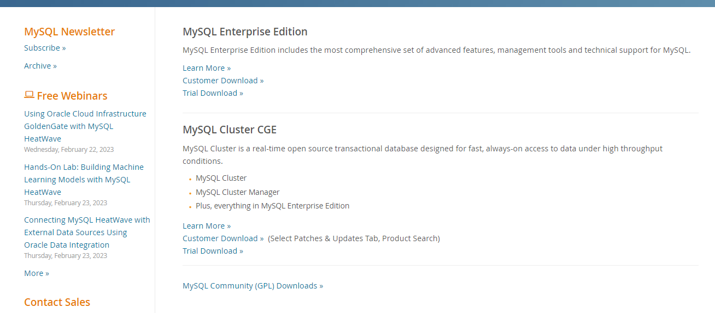

Step 2: click on the Mysql commu community downloads

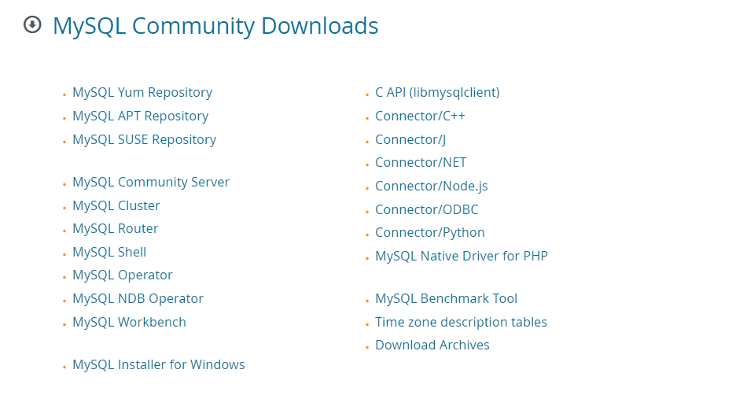

Step 3: click on Mysql installer for windows.

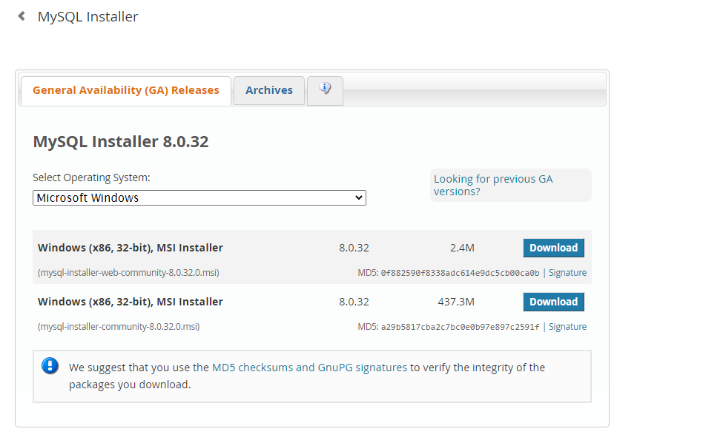

Step 4:click on the download at the bottom.

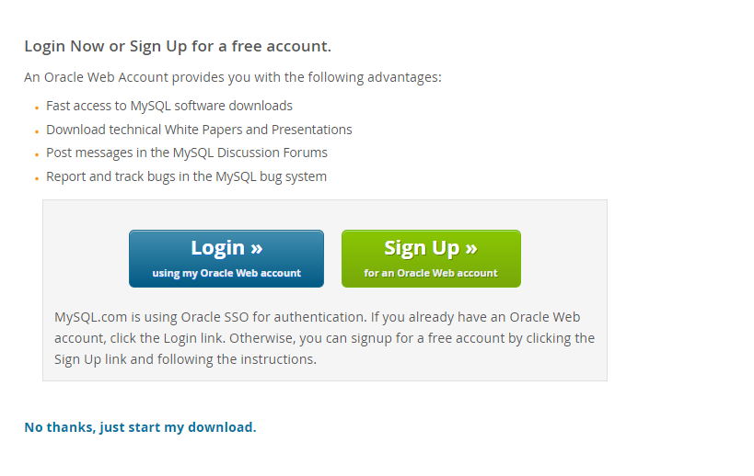

Step 5:click on No thanks, just start my download. Mysql will start downloading.After download is completed,open it and your screen will appear like this and choose custom from the following options and click next.

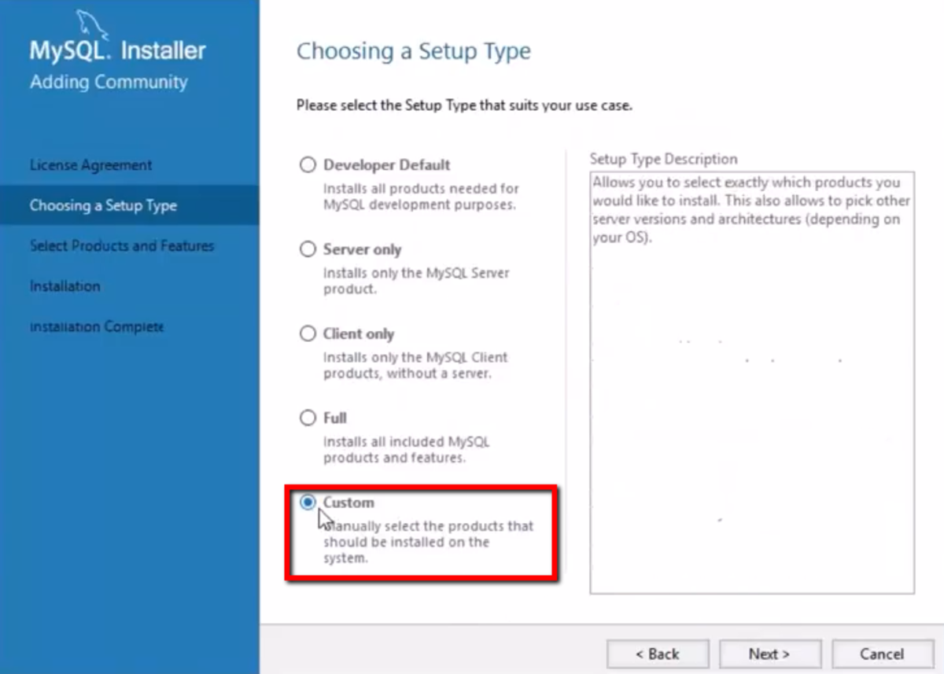

Step 6: choose server,workbench and shell and click arrow mark to add the following packages and click next.

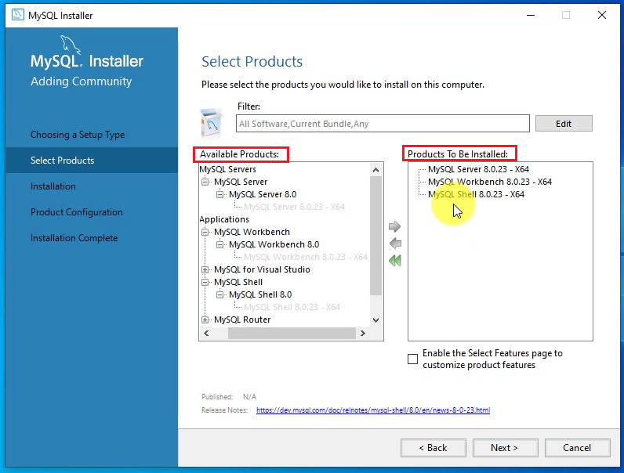

Step 7: click on execute and your download will be started.

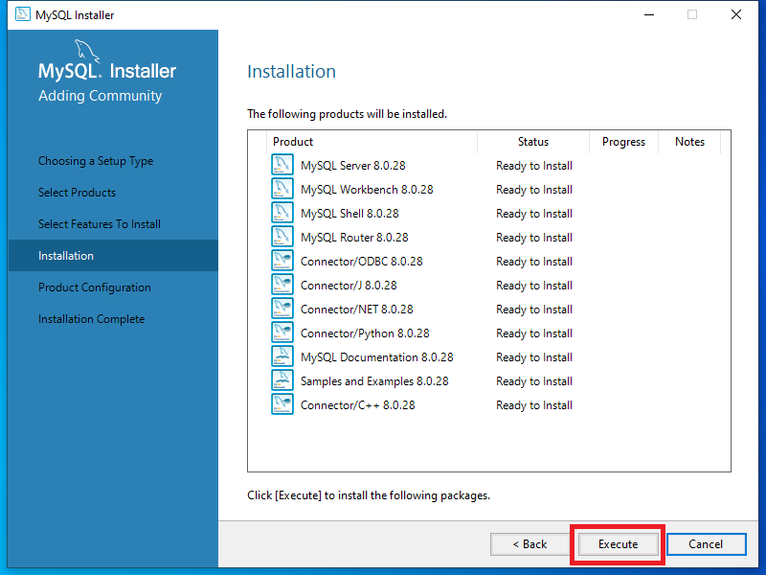

Step 8: Once completed your screen will appear like this.

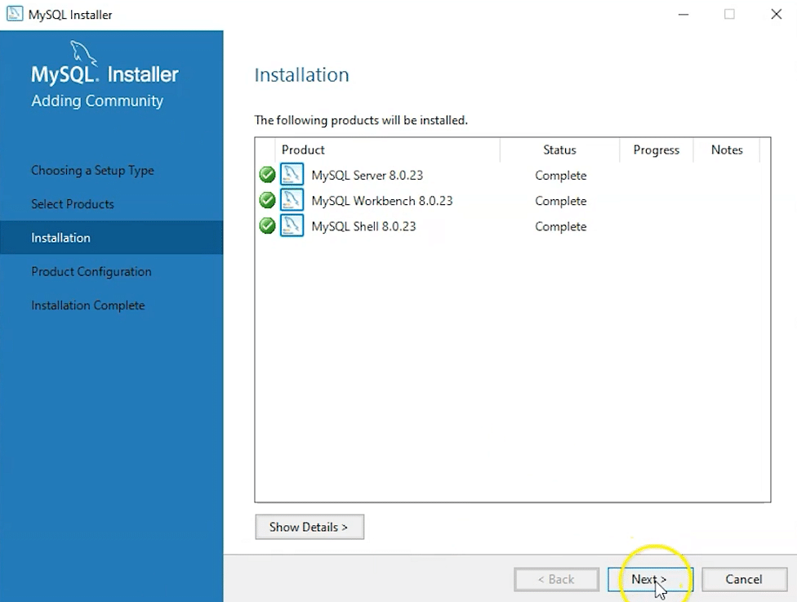

Step 9: click next and set the port number as 3306 .

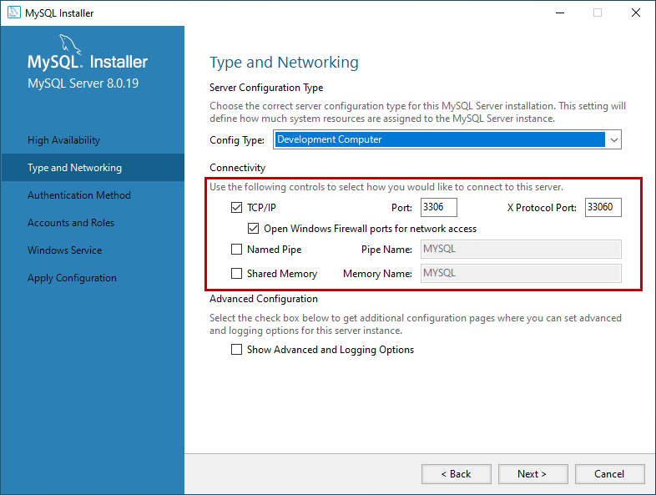

Step 10: select use strong password and click next.

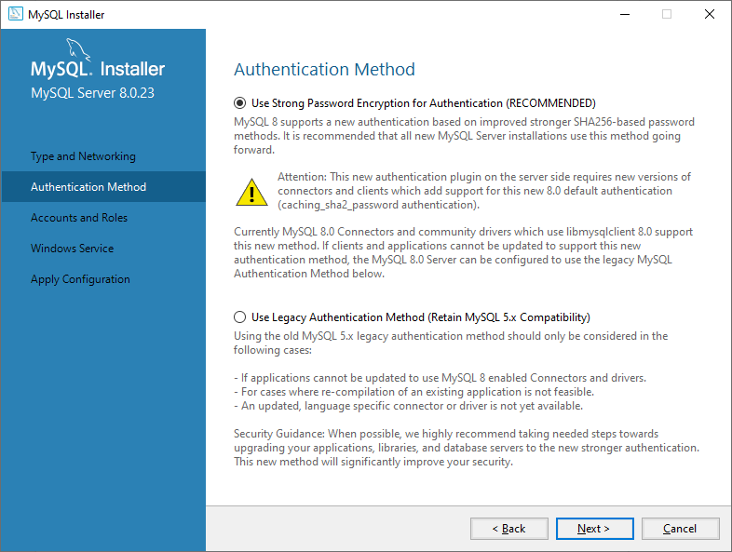

Step 11: set password and click next.

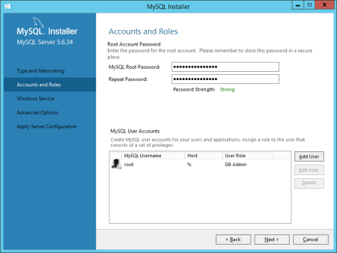

Step 12: set Mysql service name as MYSQL80.

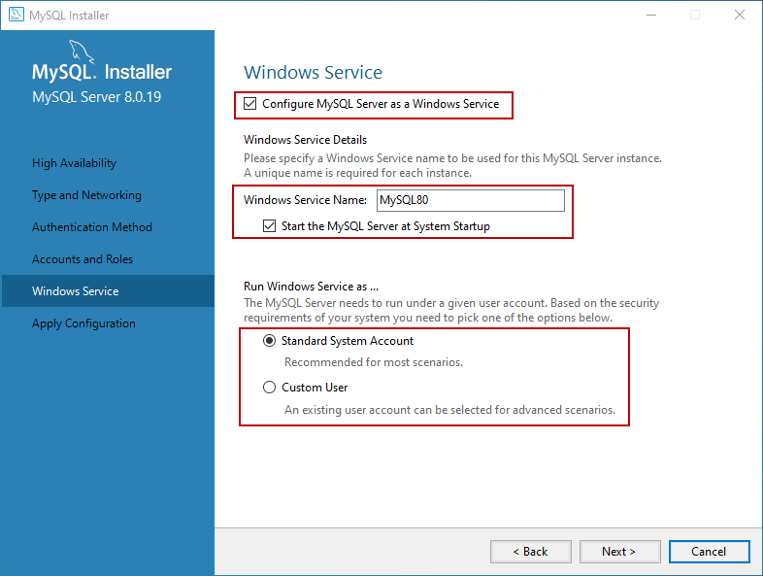

Step 13: select default and click on next.

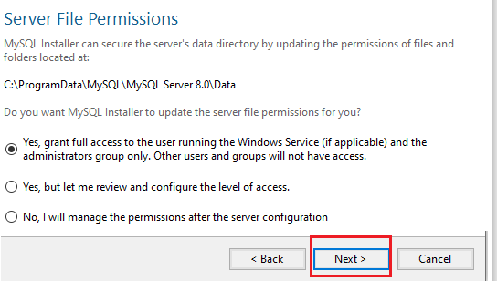

Step 14: click on execute and it will finish executing.

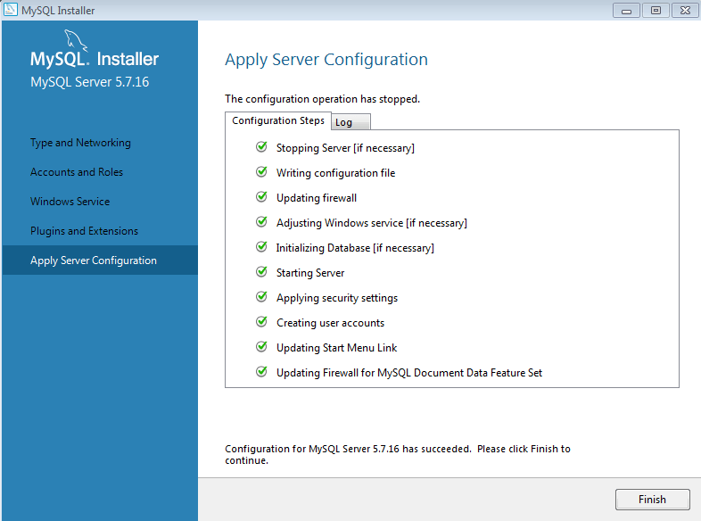

Step 15: click on next.

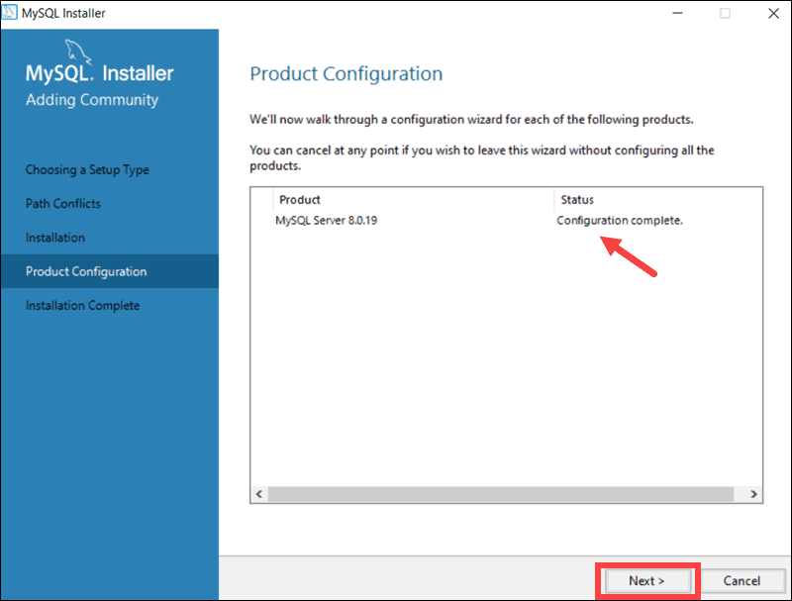

Step 16:click on finish.

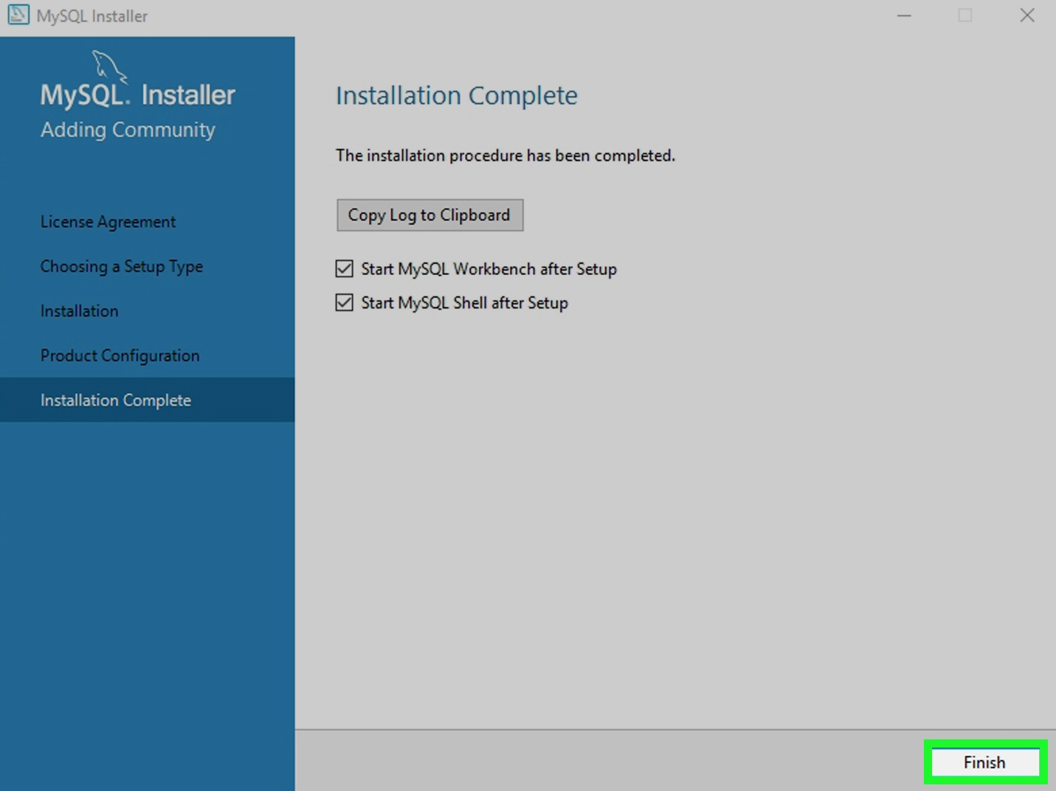

**8. SYSTEM STUDY AND TESTING**

**8.1 Feasibility Study**

The feasibility of the project is analysed in this phase and business proposal is put forth with a very general plan for the project and some cost estimates. During system analysis the feasibility study of the proposed system is to be carried out. This is to ensure that the proposed system is not a burden to the company. For feasibility analysis, some understanding of the major requirements for the system is essential.

Three key considerations involved in the feasibility analysis are

* Economical feasibility
* Technical feasibility
* Social feasibility

**Economical Feasibility**

This study is carried out to check the economic impact that the system will have on the organization. The amount of fund that the company can pour into the research and development of the system is limited. The expenditures must be justified. Thus the developed system as well within the budget and this was achieved because most of the technologies used are freely available. Only the customized products had to be purchased.

### **Technical Feasibility**

This study is carried out to check the technical feasibility, that is, the technical requirements of the system. Any system developed must not have a high demand on the available technical resources. This will lead to high demands on the available technical resources. This will lead to high demands being placed on the client. The developed system must have a modest requirement, as only minimal or null changes are required for implementing this system.

**Social Feasibility**

The aspect of study is to check the level of acceptance of the system by the user. This includes the process of training the user to use the system efficiently. The user must not feel threatened by the system, instead must accept it as a necessity. The level of acceptance by the users solely depends on the methods that are employed to educate the user about the system and to make him familiar with it. His level of confidence must be raised so that he is also able to make some constructive criticism, which is welcomed, as he is the final user of the system.

### **System Testing**

The purpose of testing is to discover errors. Testing is the process of trying to discover every conceivable fault or weakness in a work product. It provides a way to check the functionality of components, sub-assemblies, assemblies and/or a finished product It is the process of exercising software with the intent of ensuring that the

Software system meets its requirements and user expectations and does not fail in an unacceptable manner. There are various types of test. Each test type addresses a specific testing requirement.

**8.2 Types of Tests**

**8.2.1 Unit testing**

Unit testing involves the design of test cases that validate that the internal program logic is functioning properly, and that program inputs produce valid outputs. All decision branches and internal code flow should be validated. It is the testing of individual software units of the application .it is done after the completion of an individual unit before integration. This is a structural testing, that relies on knowledge of its construction and is invasive. Unit tests perform basic tests at component level and test a specific business process, application, and/or system configuration. Unit tests ensure that each unique path of a business process performs accurately to the documented specifications and contains clearly defined inputs and expected results.

**8.2.2 Integration testing**

Integration tests are designed to test integrated software components to determine if they actually run as one program. Testing is event driven and is more concerned with the basic outcome of screens or fields. Integration tests demonstrate that although the components were individually satisfaction, as shown by successfully unit testing, the combination of components is correct and consistent. Integration testing is specifically aimed at exposing the problems that arise from the combination of components.

Software integration testing is the incremental integration testing of two or more integrated software components on a single platform to produce failures caused by interface defects.

The task of the integration test is to check that components or software applications, e.g. components in a software system or – one step up – software applications at the company level – interact without error.

**Test Results:** All the test cases mentioned above passed successfully. No defects encountered.

**Acceptance Testing**

User Acceptance Testing is a critical phase of any project and requires significant participation by the end user. It also ensures that the system meets the functional requirements.

**Test Results:** All the test cases mentioned above passed successfully. No defects encountered.

**8.2.3 Functional testing**

Functional tests provide systematic demonstrations that functions tested are available as specified by the business and technical requirements, system documentation, and user manuals.

Functional testing is centered on the following items:

Valid Input : identified classes of valid input must be accepted.

Invalid Input : identified classes of invalid input must be rejected.

Functions : identified functions must be exercised.

Output : identified classes of application outputs must be exercised.

Systems/Procedures: interfacing systems or procedures must be invoked.

Organization and preparation of functional tests is focused on requirements, key functions, or special test cases. In addition, systematic coverage pertaining to identify Business process flows; data fields, predefined processes, and successive processes must be considered for testing. Before functional testing is complete, additional tests are identified and the effective value of current tests is determined.

**9.2.4 White Box Testing**

White Box Testing is a testing in which in which the software tester has knowledge of the inner workings, structure and language of the software, or at least its purpose. It is purpose. It is used to test areas that cannot be reached from a black box level.

**9.2.5 Black Box Testing**

Black Box Testing is testing the software without any knowledge of the inner workings, structure or language of the module being tested. Black box tests, as most other kinds of tests, must be written from a definitive source document, such as specification or requirements document, such as specification or requirements document. It is a testing in which the software under test is treated, as a black box .you cannot “see” into it. The test provides inputs and responds to outputs without considering how the software works.

**Test objectives**

* All field entries must work properly.
* Pages must be activated from the identified link.
* The entry screen, messages and responses must not be delayed.

**Features to be tested**

* Verify that the entries are of the correct format
* No duplicate entries should be allowed
* All links should take the user to the correct page.

1. **CONCLUSION**

Ultimately the proposed scheme reduces the manpower, workload on staff. It benefits all the educational institutes by reducing the complexity involved while allocating the exam duty for the staff and examination class rooms for the students. All these data is stored in a centralized database which can be accessed whenever needed. Further the proposed methodology used the efficient algorithm which is highly scalable. This can automate the manual work involved in assigning the invigilation duty and class room arrangement during university examination.

**FUTURE ENHANCEMENT**

It is quite obvious that tomorrow’s invigilation system will tend to rely more on technology. With the introduction of the next generation apps and online services, exam details is going to get further accessible and enjoyable.

Automated scheduling: One enhancement could be to incorporate automated scheduling functionality into the system, so that it can assign invigilation duties to staff members based on their availability and qualifications. This would save time and reduce errors associated with manual scheduling.

Mobile access: It may also be useful to add mobile access to the system, allowing invigilators to access their duty schedules, exam details, and other relevant information from their mobile devices. This would improve convenience and reduce the likelihood of miscommunication.

**11.REFERANCES**

[1] S. Priya Dharshini, M. Selva Sudha, Mrs. V. Anithalakshmi, “Exam Cell Automation System,” International Journal of Engineering Science and Computing (2017), Volume 7, Issue no3.

[2] Dayanand G Savakar, Ravi Hosur, “Automation of Examination System”, International Journal of Science and Research, Volume 4 Issue 11 November 2015.

[3] DigitalPersona Incorporation (2012), Best Practices for implementing Fingerprint Biometrics in Application. A Whitepaper

[4] Josphineleela R. and Ramakrishnan M. (2012). An efficient Automatic system using Fingerprint Reconstruction Technique. International Journal of Computer Science and Information Security, 10(3):1-6

[5] Indu Sharma, Anjali Singhal, Research on Online Examination System, International Journal of Engineering Technology, Management and Applied Sciences,Volume 2 Issue 3, August 2014

[6] Ong, M. L., Liew, L. H. and Sim, J. (2006). Examination Invigilation Scheduling System In Optimising Lecturers’ Preference. UiTM Sarawak: Unit of Research, Development, and Commercialization (URDC), Sarawak: University Teknologi Mara